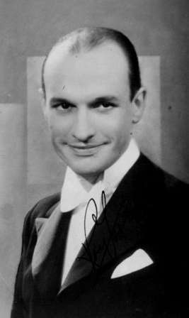
Roy Fox
And his
Orchestra
Whispering
With the vocal talents of - Mary Lee, Peggy Dell, Denny Dennis, Barry Gray, Sid Buckman, Jack Plant
BRA CD 01
Roy Fox and His Orchestra Whispering
BRA CD01

MONO
Roy Fox and His Orchestra Whispering

BRA CD01
MONO
Roy Fox and His Orchestra - Whispering

- Whispering – Part 1 Denny Dennis HMV BD 391 16/11/36
- Whispering – Part 2 Denny Dennis HMV BD 391 16/11/36
- If Your Father Only Knew Sid Buckman Decca F5591 27/1/35
- It’s Got To Be Love Mary Lee HMV BD 5161 29/12/36
- San Felipe Denny Dennis Decca F5591 27/1/35
- I’ll Sing You A Thousand Love Songs Barry Gray HMV BD 5138 16/11/36
- Over my Shoulder Peggy Dell Decca F5081 4/5/34
- South Sea Island Magic Denny Dennis HMV BD 5108 12/9/36
- I Heard A Song In A Taxi Denny Dennis HMV BD 5108 12/9/36
- I’ve Got Beginner’s Luck Mary Lee HMV BD 5224 29/5/37
- With Plenty Of Money And You Denny Dennis HMV BD 5210 15/4/37
- If I Should Lose You Denny Dennis HMV BD 5025 24/1/36
- I Love To Whistle Mary Lee HMV BD5367 17/5/38
- Goodnight, Little Girl Of My Dreams Jack Plant Decca F3688 6/10/33
- Everybody Loves My Marguerite Sid Buckman Decca F3688 6/10/33
- We’ll All Go Riding On A Rainbow Peggy Dell Decca F 3729 13/10/33

Tracks 1 and 2 feature Denny Dennis with the ‘Whisperers’, Mary Lee and Barry Gray. Jackie Keller provides the whistling on track 13.

Whispering cornettist Roy Fox arrived in Britain in the early 1930s. He soon led one of the finest dance bands at the Monseigneur Restaurant in Piccadilly, featuring Al Bowlly as his main vocalist. Following a spell of illness, he formed a new band that went on to make some of the finest dance band recordings of the 1930s, featuring an array of talented musicians and vocalists. Roy disbanded in 1938 and this wonderful band came to an end. Thankfully, we can enjoy their legacy of wonderful recordings.

Source – 78 rpm recordings. Some slight surface noise may be evident due to the age and rarity of these recordings. This should not detract from the enjoyment of these classic vintage recordings.

